Application Layer
The underlying layers behind the application layer are primarily responsible for delivering transport services, but without directly engaging in actual tasks for end users. The Applications Layer facilitates user interaction with the network.
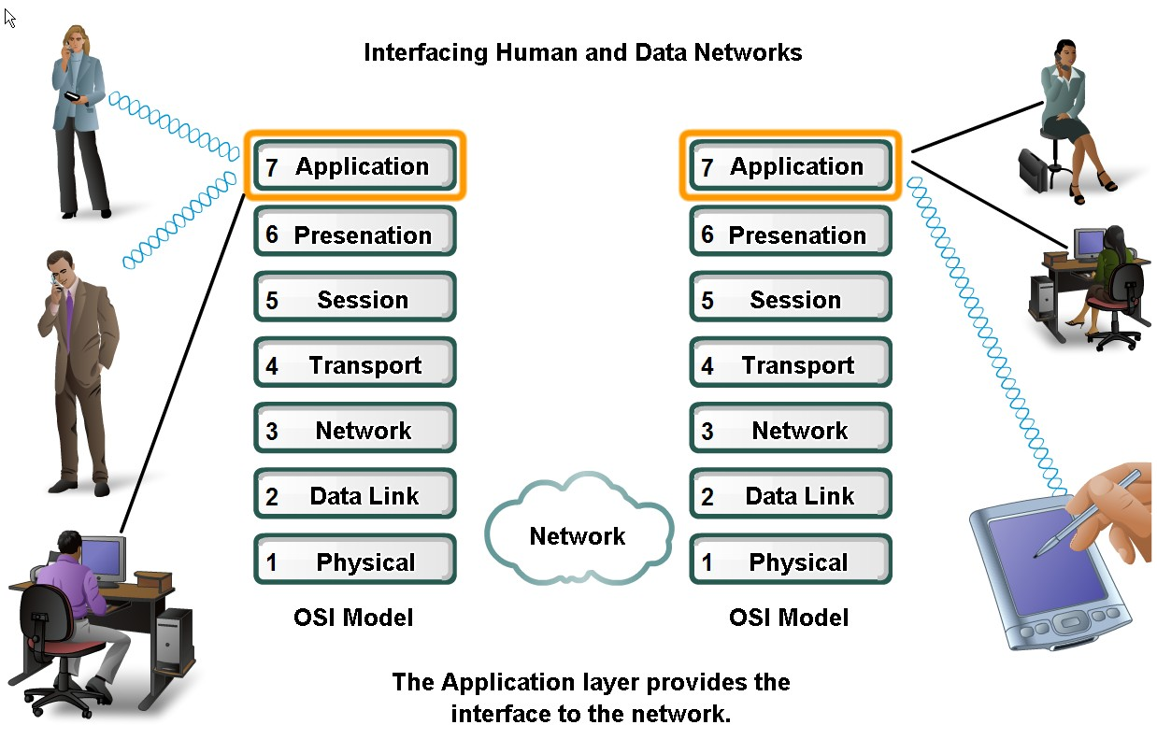
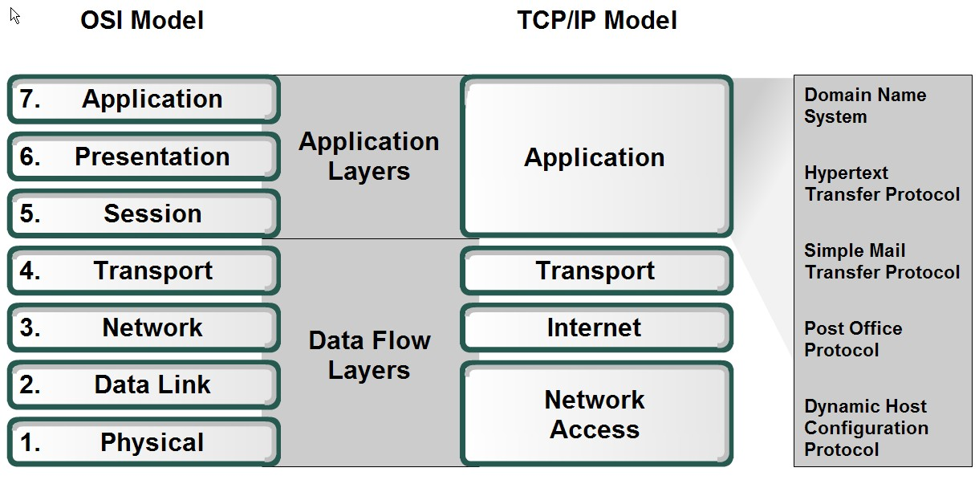
THE DOMAIN NAME SYSTEM
Web pages are accessed by utilising the IP addresses of the machines on which they are stored, these addresses are hard for users to remember. The organization's web server may potentially be identified as www.cs.washington.edu, irrespective of its assigned IP address. In order for the network to effectively process information, it is necessary to provide a system that facilitates the conversion of names into numerical network addresses. During the early stages of ARPANET, a file named hosts.txt was used to provide a comprehensive list of machine names and their corresponding IP addresses. Each evening, the hosts would get the data from the designated website. This solution demonstrated satisfactory performance for a network of several hundred devices. Still, this strategy could not continue to function long until hundreds of millions of PCs were online. Eventually, the file would get too big. In the absence of central name management, host name disputes would arise on a regular basis. The Domain Name System, or DNS, was created in 1983 as a solution to these issues. The creation of a distributed database system for implementing a hierarchical, domain-based naming scheme is the fundamental component of DNS. The main usage for it is to translate IP addresses into host names. An application programme runs the resolver library operation, supplying the name as an argument, to map a name to an IP address. Once the local DNS server has looked up the name, the resolver sends a query containing the name to it. The resolver then returns the IP address to the caller.
DNS Name Space:
Name management in the postal system is accomplished by requiring letters to include the addressee's name, street address, nation, state, or province, and city. DNS functions in the same manner. The Internet Corporation for Assigned Names and Numbers, or ICANN, is in charge of overseeing the top naming hierarchy for the Internet. Over 250 top-level domains make up the Internet, and each domain includes a large number of hosts. Every domain is divided into subdomains, which are then divided yet further, and so on. There are two types of top-level domains: countries and generic.
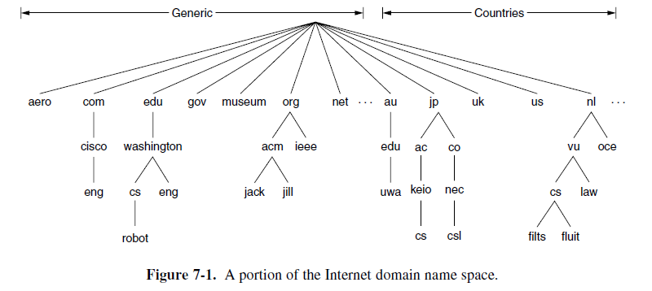
ICANN-appointed registrars are in charge of overseeing the top-level domains. To get a name, all you have to do is visit the relevant registrar (for com in this example) and see whether the name you want is accessible.
The requester obtains the name by paying a nominal yearly fee to the registrar. Each nation has a single entry in the country domains. For instance, the.in domain is open to anyone and is used by businesses, people, and organisations throughout India. For instance: You may reach Cisco's engineering department at eng.cisco.com.
Domains may be added to the tree in either national or generic domains, in theory. It takes authorization from the domain it will be included in to establish a new domain. For instance, authorization from the person in charge of managing cs.washington.edu is required if a new VLSI group at the University of Washington want to use the domain name vlsi.cs.washington.edu.
Domain Resource Records:
Each domain may be linked to a collection of resource entries. The resource records linked to a domain name are returned to a resolver when it submits the name to DNS. Thus, mapping domain names to resource entries is DNS's principal purpose. A five-tuple makes up a resource record. The structure is as follows:
Name of domain Duration of life Class Type Value
cs.mit.edu 86400 IN CNAME, for instance csail.mit.edu. The domain to which this record belongs is indicated by the domain name. As a result, the main search key that answers queries is this field. The record's stability is indicated by the Time to Live field. The Class is the third field in each resource record. Information on the Internet is always IN. What sort of record this is indicated by the Type column? DNS records come in a variety of forms.
The A (Address) record is the most significant sort of record. It contains a host's interface's 32-bit IPv4 address.
The matching 128-bit IPv6 address is included in the AAAA, or "quad A," record. The MX record is a typical record type. It includes the host name that is ready to receive email for the given domain. The sending host must identify a mail server at microsoft.com that is ready to receive emails in order to send an email to, say, bill@microsoft.com. This information may be found in the MX record.
CNAME records allow aliases to be created. Example: cs.mit.edu 86400 IN CNAME csail.mit.edu
Name Servers:
A single name server could theoretically store the whole DNS database and be able to answer any requests about it. In actuality, this server would be rendered ineffective due to overload. Moreover, the whole Internet would be totally inoperable if it ever went down. The DNS name space is separated into non-overlapping zones to prevent the issues that arise from having only one source of information.
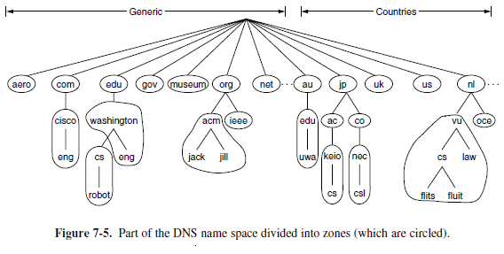
One or more name servers are also connected to each zone. The zone's database is stored on these hosts.
Name resolution is the process of searching up a name and locating an address. A local name server receives queries from resolvers about domain names. The authoritative resource records are returned if the domain being requested is within the control of the name server, e.g., top.cs.vu.nl falls under cs.vu.nl.
What takes place when the domain is remote? If the name server doesn't already have information about the domain saved locally and flitts.cs.vu.nl wants to find the IP address of robot.cs.washington.edu at the University of Washington, it starts a remote query. Next, ask one of the main name servers. This will put you at the very top of the name system. The name servers for these top-level domains know about each one.
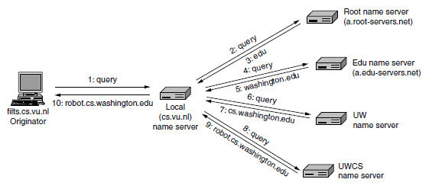
In order to establish communication with a root server, it is necessary for each name server to possess relevant information on one or more root name servers. The total number of root DNS servers is 13, which are often referred to as a-root-servers.net through m.root-servers.net. It is unlikely that the root name server has knowledge of the machine address at the University of Washington (UW), and it is also impossible that it has information on the name server for UW. However, it is necessary to figure out the name server for the edu domain, where cs.washington.edu is situated. In step 3, the response includes the identification of the name and IP address. Subsequently, the name server at the local level proceeds with its search. The whole inquiry is sent to the educational name server, namely a.edu-servers.net. The above-mentioned name server provides the name server information for the University of Washington. This is shown in stages four and five. Subsequently, the local name server proceeds to transmit the query to the University of Washington (UW) name server, so advancing to step 6 in the process. In the event that the desired domain name belongs to the English department, the solution might be located inside the UW zone, which encompasses the English department. However, the Computer Science department has made the decision to independently operate its own name server. The query yields the name and IP address of the University of Washington Computer Science name server at step 7.
In the last stage, the local name server initiates queries to the UW Computer Science name server. The server in question has authoritative control over the domain cs.washington.edu, thereby indicating its capability to provide the necessary response. The local name server delivers the final answer (step 9) to flits as a response. The website cs.vu.nl is accessed in step 10.
EMAIL
The email system is made up of two types of subsystems: user agents and message transfer agents. User agents let people read and send email, and message transfer agents move data from the sender to the receiver. The user agent gives people a way to connect with the email system through a graphical user interface. Google Gmail, Microsoft Outlook, and Apple Mail are just a few of the well-known user interfaces. It lets you write messages and answers to messages, see what messages are coming in, and organise messages by filing, finding, and getting rid of them. Users' mailboxes are where they store the emails they get. Mail systems take care of them. It is possible to send, receive, and respond to messages, as well as change the settings for folders, using a user agent. Most user agents can handle mailboxes that have more than one place for saved mail. It's also possible for the user agent to file messages before the user even reads them. A lot of businesses and ISPs have software that sorts mail into two groups: important and spam. Mail creation is one of the most basic things that user agents allow. Making messages and replies to messages and sending them is part of it. In most cases, editors are built into the user agent so that it can help with addressing. For instance, when you react to a message, the email system can pull out the sender's address from the incoming message and put it in the right place in your reply immediately. User agents do nothing more than show people what's in their mailboxes.
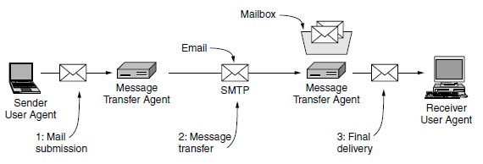
The package and its contents make up a message structure. The message is inside the paper. It has the target address, importance, and security level, among other things, so that the letter can be sent. There are two parts to the message inside the envelope: the title and the body. The header tells the user agents how to control the page. The body is for the human recipient.
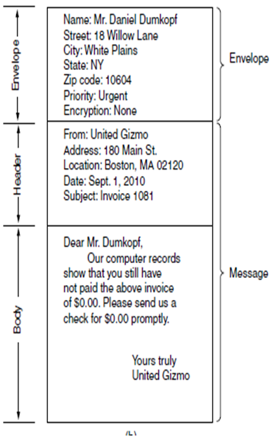
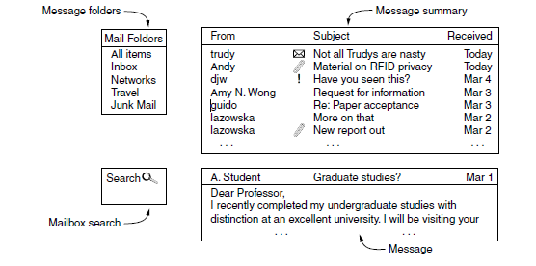
The displayed information in the lines is organised in a certain sequence, namely the From, Subject, and Received fields. This arrangement allows for the identification of the sender, the subject matter of the message, and the time of its reception. The symbols next to the message topics may serve as indicators, such as denoting unread correspondence (represented by an envelope icon), the presence of attached files (represented by a paperclip icon), and the classification of messages as significant, among other possibilities. Once a message has been perused, the user has the agency to choose the subsequent course of action. This phenomenon is referred to as message disposition.
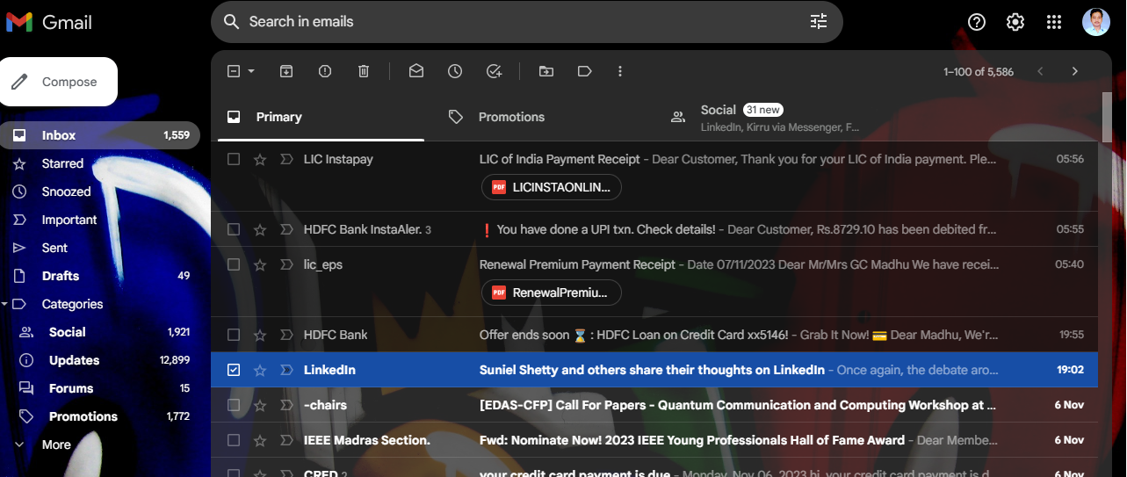
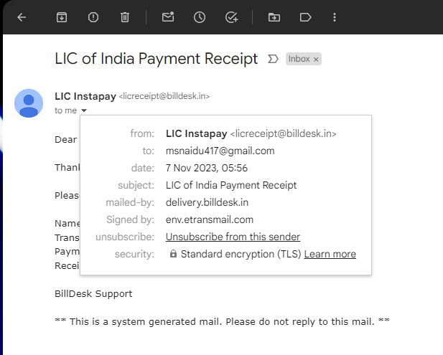
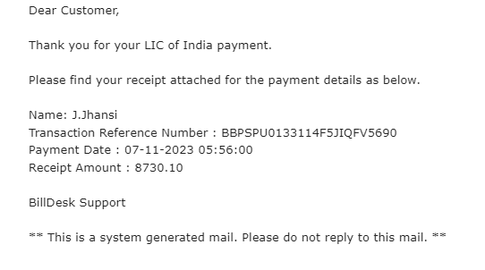
Messages are composed of a basic envelope, which includes header information, followed by the message content. Every header field is composed of a field name followed by a colon. Typically, the user agent constructs a message and transfers it to the message transfer agent, which then utilises certain header information to assemble the physical envelope. The principal header fields related to message transport are listed as
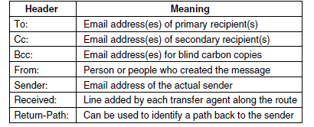
The "To:" column contains the Domain Name System (DNS) address of the principal recipient, for example, xyz@vidyanikethan.edu. The Cc field in an email message contains the email addresses of additional recipients who are not the primary receivers of the message. The Bcc (Blind carbon copy) field enables someone to discreetly transmit copies of a message to other recipients, without the knowledge of the original and secondary receivers. The last two fields, namely From: and Sender:, indicate the identity of the author and the person responsible for transmitting the message, respectively. These two entities do not necessarily have to possess identical characteristics. In some instances, a company executive may compose a message, but the responsibility of transmitting this message may be delegated to her assistant. In this scenario, the individual holding an executive position would be designated in the "From:" area, while the assistant would be indicated in the "Sender:" field. The inclusion of the From: field is mandatory, whereas the omission of the Sender: field is permissible provided it corresponds to the same information as the From: field.
The message transfer agents (MTAs) operate in the background on mail servers, fulfilling the task of autonomously facilitating the movement of emails inside the system, from the sender to the receiver, using the Simple Mail Transfer Protocol (SMTP).Message transfer agents (MTAs) are responsible for the implementation of mailing lists, which include the distribution of an exact replica of a message to all individuals included in a designated list of email addresses. Additional sophisticated functions include the use of carbon copies, blind carbon copies, and alternate receivers in cases when the principal recipient is presently unavailable.
The transmission of mail occurs via the exchange of messages between message transfer agents, according to a universally accepted format. This feature provides compatibility for multimedia material and enables the inclusion of foreign text. The term used for this particular system is MIME. The Multipurpose Internet Mail Extensions (MIME) is a standard that allows for the exchange of different types of data over the Internet. During the first stages of the ARPANET, the email system only accommodated the English language. With the emergence of the internet and the increasing need to transmit various forms of material via electronic mail, the existing technique became insufficient. The issues included the transmission and reception of messages in languages other than the user's native language, such as Chinese and Japanese. Additionally, challenges were encountered when attempting to transmit messages that did not consist of textual content, such as audio recordings or photos.
The resolution included the creation of MIME (Multipurpose Internet Mail Extensions). The use of this technology is prevalent in the transmission of electronic mail messages via the Internet. The MIME specification encompasses the definition of five distinct message headers. The first field of the message serves to inform the user agent that it is encountering a MIME message and specifies the version of MIME being used. In the absence of a MIME-Version: header, it is presumed that every message is an English plaintext message.
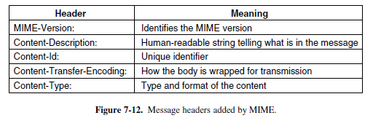
The Content-Description is an ASCII string that provides a description of the content included inside the message. The inclusion of a header is necessary to provide the receiver with an indication of the message's value and significance, so assisting them in determining if it is worthwhile to invest effort in decoding and reading its contents. The Content-Id header serves as an identifier for the content. The Content-Transfer-Encoding header specifies the method by which the body of a message is encapsulated for transmission over a network. The Content-Type header is used to indicate the format or type of the message body.
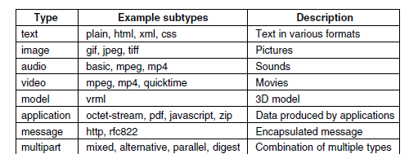
The following MIME type relates to images, serving as a means to transport static visual representations. Currently, a variety of formats are extensively used for the storage and transmission of photographs, including both compressed and uncompressed options. A number of image formats, such as GIF, JPEG, and TIFF, are inherently integrated inside the majority of web browsers.
Message Transfer:
Having provided an overview of user agents and mail messages, we can now proceed to examine the process by which message transfer agents facilitate the transmission of messages from the sender to the receiver. The process of transferring electronic mail is facilitated by the Simple Mail Transfer Protocol (SMTP).One of the most straightforward methods for message transmission is the establishment of a transport link between the source and destination machines, followed by the direct transfer of the message.
SMTP (Simple Mail Transfer Protocol) and Extensions:
In the realm of the internet, electronic mail (email) is sent via the establishment of a Transmission Control Protocol (TCP) connection between the originating computer and the destination computer's port 25. The system in question operates as a mail server, namely using the Simple Mail Transfer Protocol (SMTP). The server has the capability to receive incoming connections and process messages for subsequent transmission.
Once the Transmission Control Protocol (TCP) connection to port 25 has been established, the computer that initiates the connection, referred to as the client, and the machine that receives the connection, referred to as the server. When the server is amenable to receiving email, the client proceeds to declare the intended recipient(s) to whom the email is being sent. If a receiver is present at the designated location, the server grants permission to the client to transmit the message. Subsequently, the client transmits the message, and the server duly confirms its receipt. The outgoing mail transfer agent establishes a Transmission Control Protocol (TCP) connection on port 25 with the Internet Protocol (IP) address of the mail server in order to communicate with the receiving mail transfer agent. This communication is facilitated using the Simple Mail Transfer Protocol (SMTP) for the purpose of relaying the message. Subsequently, the mail transfer agent responsible for receiving will proceed to allocate the incoming mail to the appropriate mailbox designated for the user named Bob, so enabling him to peruse its contents at a later moment. IMAP and POP are two distinct protocols used for email retrieval. The suggested approach for accessing emails from many devices, such as smartphones, laptops, and tablets, is via the use of IMAP (Internet Message Access Protocol).
THE WORLD WIDE WEB
The World Wide Web is comprised of a global collection of information presented in the format of web pages. The World Wide Web serves as a comprehensive infrastructure that facilitates the retrieval and navigation of interconnected information distributed over a vast network of Internet-connected devices. Every individual page has the potential to have hyperlinks that connect to other sites located anywhere around the globe. Individuals have the ability to access a webpage by engaging with a hyperlink via the action of clicking on it. This action directs them to the specific webpage that the hyperlink is referencing. Web pages are often accessed and displayed using a software application known as a web browser. Firefox, Internet Explorer, and Chrome exemplify prevalent web browsers. The web browser retrieves the specified webpage and presents it on the screen in a correctly structured manner. Certain sections of the webpage are interconnected via hyperlinks leading to further webpages. A hyperlink refers to a textual or visual element, such as a piece of text, symbol, or picture, which is linked to another webpage. In order to access a hyperlink, the user positions the mouse pointer over the designated connected section of the webpage and initiates a click.
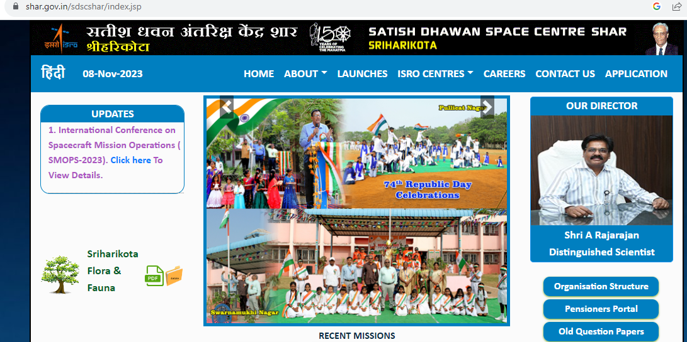
If you click on a link, it just tells your computer to get another page. To get a page, you send a request to one or more computers. The servers then send back the page's information. As shown in the figure, the computer calls up cs.washington.edu, youtube.com, and google-analytics.com to get the two pages. The browser takes the information from these different sites and puts it all together.
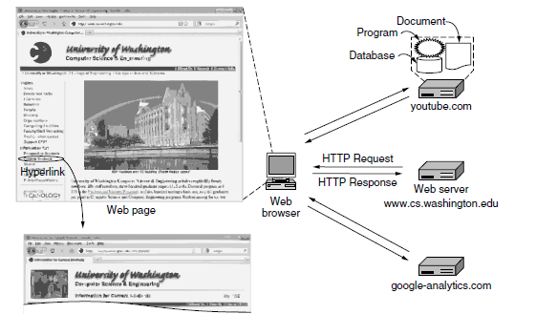
The current scenario comprises the main page being provided by the cs.washington.edu server, an embedded video being provided by the youtube.com server, and nothing visible to the user being provided by the google-analytics.com server other than the ability to monitor site visits. HTTP (Hypertext Transfer Protocol) is a straightforward text-based request-response protocol used to retrieve pages. It's possible that the material is just a static document that appears the same each time. Each time a dynamic website is presented, it could look different. For instance, every visitor to an electrical shop can get a distinct front page. If a consumer has previously purchased mystery books, they are likely to see new thrillers prominently promoted when they visit the store's home page. Mechanisms for identifying and finding pages were necessary for web pages. Before a chosen page could be shown, the following three questions had to be answered: 1. What is the name of the page? 2. What is the address of the page? 3. How do you go to the page? Uniform Resource Locators, or URLs, are given to each page and function as the page's global name.
Three components make up a URL: the path that uniquely identifies the particular page, the DNS name of the computer hosting the page, and the protocol. For instance, the webpage seen in Figure may be accessed via http://www.cs.washington.edu/index.html. The host's DNS name (www.cs.washington.edu), the path name (index.html), and the protocol (http) make up this URL.
Let's go through the actions that take place when we click on our sample link:
The browser goes through a number of actions when a user clicks on a hyperlink in order to get the page it points to.
The URL is determined by the browser.
The IP address of the server www.cs.washington.edu is requested by the browser via DNS.
DNS returns 128.208.3.88 in response.
4. The web browser establishes a TCP connection to 128.208.3.88 via port 80, which is a well-known HTTP protocol port.
5. An HTTP request is sent, requesting the page /index.html.
It is simple for browsers to utilise several protocols to access different types of resources thanks to the URL architecture. Indeed, many different protocols have specified URLs.
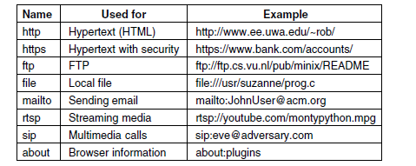
Any page must have its format understood by the browser in order for it to be displayed. Web pages are written in a standardised language called HTML so that all browsers can read them. The majority of browsers have a variety of buttons and features designed to facilitate Web browsing. Most contain buttons to advance to the next page and to go back to the previous page.
A page might include any one of hundreds of different file formats, such as an MPEG movie, a PDF document, a JPEG picture, MP3 music, or a paper. The common markup language used to create Web pages is HTML. The components that make up HTML are many. The browser is instructed on how to display material using HTML elements.

